Accreditation & Certification
THE DIFFERENCE BETWEEN ACCREDITATION and CERTIFICATION
Probably the most knowledgeable agronomic expert in Australia is “Peter McMaugh”. He has recently written an article that appeared in the Australian Turfgrass Management magazine qualifying certification. Below we have adapted some of that for the benefit of our members.
He states that “In its simplest terms certification as a guarantee. It guarantees that what you what you order is what you get, and that what is produced under tightly controlled conditions (rules) are protected and enforced by regular independent inspections”.
He also qualifies; that to date in Australia there has been no genuine fully-fledged “true” Certification scheme for vegetatively propagated turfgrass varieties.
PBR (Plant Breeders Rights) is the protection of the owner of the rights and not the protection of the end user. Under the BR at when a person or entity is awarded ownership of a plant variety, there is an obligation that requires access license holders to pure stock. By two providers can result in the loss of license.
The characteristics of ‘Certification’ means that you cannot have a ‘certified; farm producing ‘certified’ products you can only have certified paddocks, clearly identified by GPS coordinates which contain a specific quantity of a specific grass variety.
This is where Certification shows clear differences from schemes of Accreditation.
Accreditation: an Accredited Turf farm should produce reliable good-quality turf on a consistent basis in line with all the appropriate regulations and legislation covering, but not limited to; business and company processes, property mapping, soil and help properties, water and irrigation system performance, pests, weed and disease management, cutting and installation processes, waste reduction, energy use efficiency, business operations and business management (PBR/Certification), workplace health and safety, communications and ongoing performance measurement.
The Turf Queensland Turf Accreditation Program is a third-party audited process that provides the end user with the knowledge that they are receiving products managed to a best practice standard thus reducing risk.
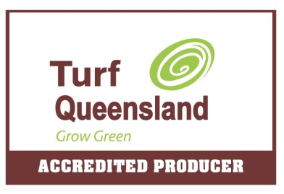
Certification: ensures that you are getting the best quality of the variety of grass you have selected to suit your needs and at time of leaving the property is guaranteed 100% pure to that variety and is being managed by the producer. Certification ensures that the Turf producer is managing any contamination and quality of the species. It does not involve the Accreditation process of business and farm management processes.
It is important to understand the difference between the definitions of Certification and Accreditation.

